1. Write shell script using for loop to print the following patterns on screen

#PROGRAM

#!/bin/bash

echo "enter the pattern length"

read a

echo -n

for((i = 1; i<= a; i++))

do

for((j = 1;j <= i;j++))

do

echo -n $i

done

echo

Done

#OUTPUT

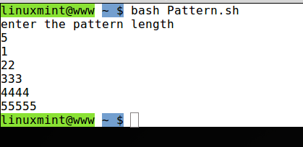

**2. Write shell script using for loop to print the following patterns on screen**

#PROGRAM

END=5

for i in $(seq 1 $END);

do

for j in $(seq 1 $i); do echo -n $j; done

echo; done

#OUTPUT

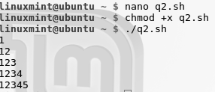

3. Write shell script using for loop to print the following patterns on screen

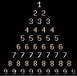

#PROGRAM

echo -n "Enter pattern length"

read N

for ((i = 1; i<N; i++))

do

for ((k=N-1; k>$i; k--))

do

echo -n " "

done

for((j = 0; j<i; j++))

do

echo -n "$i "

done

echo

done

#OUTPUT

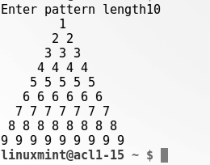

**4. Write a Shell Script to find factorial of a number.**

**#PROGRAM**

echo "Enter a number"

read num

fact=1

while [ $num -gt 1 ]

do

fact=$((fact * num)) #fact = fact * num

num=$((num - 1)) #num = num - 1

done

echo $fact

**#OUTPUT**



**5. Write a Shell Script to find "a" to the power "b" using Function.**

**#PROGRAM**

#! /bin/bash

power(){

# value of A

a=$1

# read a

# value of B

b=$2

# read b

# c to count counter

c=1

# res to store the result

res=1

if((b==0));

then

res=1

fi

if((a==0));

then

res=0

fi

if((a >= 1 && b >= 1));

then

while((c <= b))

do

res=$((res * a))

c=$((c + 1))

done

fi

# Display the result

echo -e "\n$1 to the power $2 is $res"

}

read -p "Enter value of a : " a

read -p "Enter value of b : " b

power $a $b

**#OUTPUT**

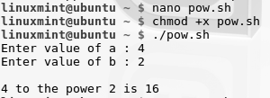

6. Write a Shell Script to find Armstrong number between 1 to 500.

#PROGRAM

#Script to find armstrong number till 50

i=1

echo "Armstrong Numbers are: "

while((i<=500))

do

c=$i

d=$i

b=0

a=0

while((c>0))

do

a=$((c%10))

b=$((b + a*a*a))

c=$((c/10))

done

if((b==d)); then

echo "$i"

fi

i=$((i+1))

Done

#OUTPUT

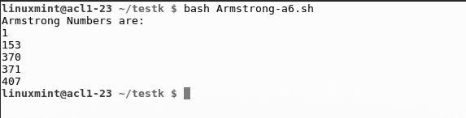

**7. Write a Shell Script to Display numbers Using Array.**

**#PROGRAM**

#!/bin/bash

echo "enter the length of array"

read a

for((i=0;i<a;i++))

do

echo "enter `expr $i + 1` number"

read arr[$i]

done

echo "the numbers you have entered are"

for((i=0;i<a;i++))

do

echo ${arr[$i]}

Done

**#OUTPUT**

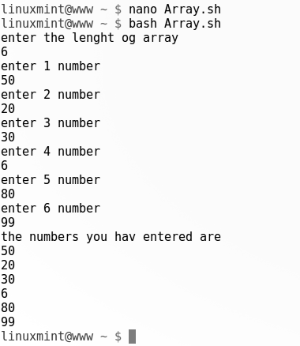

**8. Write a Shell Script to add two numbers using Function.**

**#PROGRAM**

add(){

a=$1

b=$2

return `expr $a + $b`

}

echo "enter first number"

read x

echo "enter second number"

read y

add $x $y

sum=$?

echo "Sum of $1 and $2 is $sum"

**#OUTPUT**

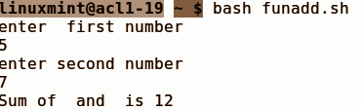

**9. Write a Shell Script to implement Bubble Sort.**

**#PROGRAM**

echo -n "Enter array size"

read N

arr=()

for(( i = 0; i < N; i++))

do

read arr[$i]

done

echo ${arr[*]}

echo "Array in original order"

echo ${arr[*]}

for ((i = 0; i<N; i++))

do

for((j = i; j<N-i-1; j++))

do

if ((${arr[j]} > ${arr[$((j+1))]}))

then

temp=${arr[$j]}

arr[$j]=${arr[$((j+1))]}

arr[$((j+1))]=$temp

fi

done

done

echo "Array in sorted order :"

echo ${arr[*]}

**#OUTPUT**

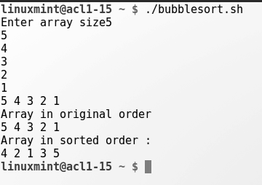

**10. Write a Shell Script to swap two numbers without using third variable.**

**#PROGRAM**

echo "enter first number"

read a

echo "enter second number"

read b

echo "Numbers before swap $a $b"

a=`expr $a + $b`

b=`expr $a - $b`

a=`expr $a - $b`

echo "Numbers after swap $a $b"

**#OUTPUT**

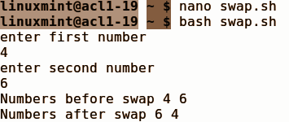

**11. Write a Shell Script to Sort Number in Descending Order.**

**#PROGRAM**

#!/bin/bash

echo -n "Enter array size "

read N

arr=()

for(( i = 0; i < N; i++))

do

read arr[$i]

done

echo ${arr[*]}

for((i = 0; i < N - 1; i++))

do

for((j = i+1; j < N; j++))

do

if((${arr[$j]} > ${arr[$i]}))

then

temp=${arr[$j]}

arr[$j]=${arr[$i]}

arr[$i]=$temp

fi

done

done

echo ${arr[*]}

**#OUTPUT**

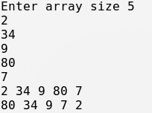

**12. Write a Shell Script to implement Insertion Sort.**

#Program

echo "enter the number"

read n

echo "enter number in an array"

for((i=0;i<n;i++))

do

read arr[$i]

done

for((i=1;i<n;i++))

do

j=$i-1

temp=${arr[$i]}

while((j>=0 && arr[j]>temp))

do

arr[$j+1]=${arr[$j]}

j=$j-1

done

arr[j+1]=$temp

done

echo "printing sorted array"

for((i=0;i<n;i++))

do

echo ${arr[$i]}

done

#OUTPUT

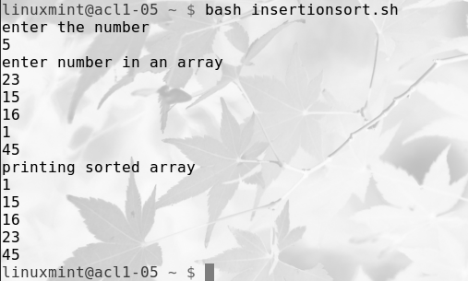

13. Write a Shell Script to implement Selection Sort.

#PROGRAM

#!/bin/bash

echo -n "Enter array size "

read N

arr=()

for(( i = 0; i < N; i++))

do

read arr[$i]

done

echo ${arr[*]}

for((i = 0; i < N - 1; i++))

do

min=$i

for((j = i; j < N; j++))

do

if((${arr[$j]} < ${arr[$min]}))

then

min=$j

fi

done

temp=${arr[$i]}

arr[$i]=${arr[$min]}

arr[$min]=$temp

done

echo ${arr[*]}

#OUTPUT

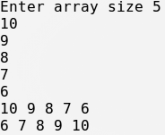

**14. Write a Shell Script to Print Fibonacci Series.**

**#PROGRAM**

echo -n "Enter number to which term fibonnaci serise is wanted:"

read N

a=0

b=1

echo "The Fibonacci series is : "

for (( i=0; i<N; i++ ))

do

echo -n "$a "

fn=$((a + b))

a=$b

b=$fn

done

**#OUTPUT**

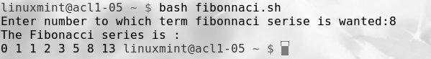

**15. Write a Shell Script to check whether a given String is Palindrome or not.**

**#PROGRAM**

echo "Enter a string to be entered:"

read str

len=`echo $str | wc -c`

len=`expr $len - 1`

i=1

j=`expr $len / 2`

while test $i -le $j

do

k=`echo $str | cut -c $i`

l=`echo $str | cut -c $len`

if test $k != $l

then

echo "String is not palindrome"

exit

fi

i=`expr $i + 1`

len=`expr $len - 1`

done

echo "String is palindrome"

**Output**

